Ever had that stomach-churning year where only half your cows calve…?

- Did you know for a profitable farm you should be aiming for 92% or more in calf rate? And with 300kg weaners selling at around $900 each, every calf lost will have a significant impact on your bottom line.

- Reports show it cost $2.21 to produce 1kg of beef last year in Victoria, so if you don’t find out as soon as possible which cows are in calf you will invest all that time, money and energy only to discover too late that there is a problem.

- The good news is pregnancy testing early gives you a huge advantage by allowing you to make management decisions to maximise your beef income.
Our pregnancy testing:
- is best done when cows are 6-16 weeks in calf.
- is accurate (when done before 16 weeks in calf)
- is quick (in good facilities we can do 60-120 cows per hour)
- is inexpensive ($3.60/cow after the first 20 cows)
- provides veterinary expertise on potential reproductive problems

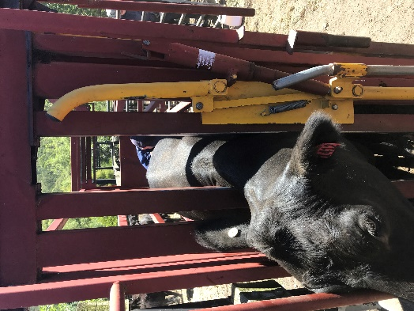
The additional benefit is it gives you options, such as:
- Sell empty cows
- Buy replacement pregnancy tested in-calf cows
- Sell extra feed
- Keep some/all weaners to fatten with extra feed

And our vets can help minimise the chance of the same problem next season by:
- Investigating which cows did not get in calf and what can be done to improve fertility
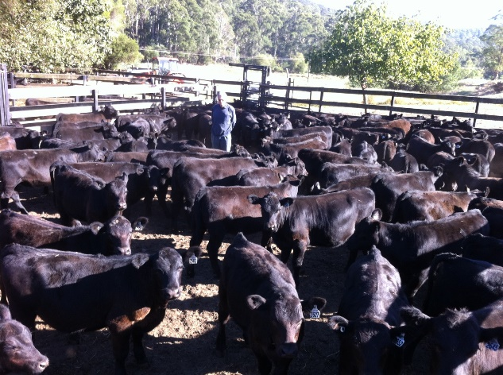
- assess bulls for reproductive problems
- assess herd for disease which may have contributed eg Pestivirus

To IMPROVE YOUR HERD PROFITABLITY GIVE US A CALL ON 0357 214 000 and make a time to talk to one of our vets so we can tailor our services to your individual needs.

