Protocol – Chronic Kidney Disease

Diagnosis
History:  May be subclinical in early CKD.  - Polyuria & polydipsia  - Weight loss  - Decreased appetite  - Lethargy  - Dehydration  - Vomiting  - Bad breath. | Physical Examination:  Can be normal in early stage CKD.  - Palpable kidney abnormalities  - Evidence of weight loss  - Dehydration  - Pale mucous membranes  - Uremic ulcers  - Evidence of hypertension, i.e. retinal haemorrhages/detachment.

Lab Work:
To diagnose Stage 1 & early Stage 2:
One or more of these findings:
- Creatinine and/or SDMA increasing over time where no prerenal cause is apparent.
- A persistent SDMA of >14 μg/dL.
- Abnormal kidney imaging.
- Persistent renal proteinuria (UPC >0.5 in dogs; UPC >0.4 in cats).
To diagnose late Stage 2 – Stage 4:
Both of these findings:
- Increased creatinine (>125 μmol/L in dogs; >140μmol/L in cats) AND increased SDMA (>18 μg/dL).
- Poorly concentrated urine (<1.030 in dogs; <1.035 in cats).
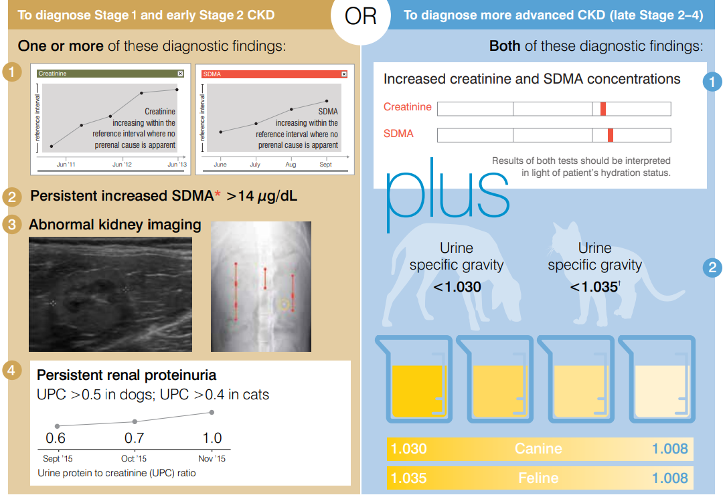

Staging of CKD
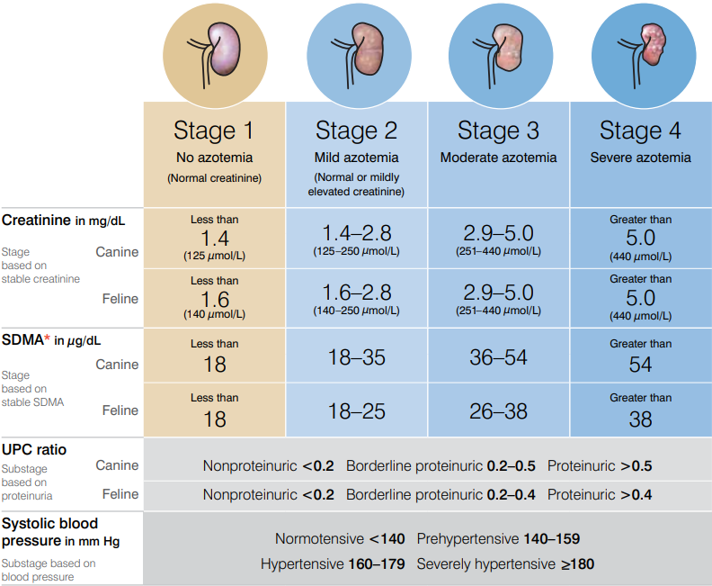
Note: In the case of staging discrepancy between creatinine and SDMA, consider patient muscle mass and retesting both in 2–4 weeks.
If values are persistently discordant, consider assigning the patient to the higher stage.

Treatment

General Treatment Guidelines:
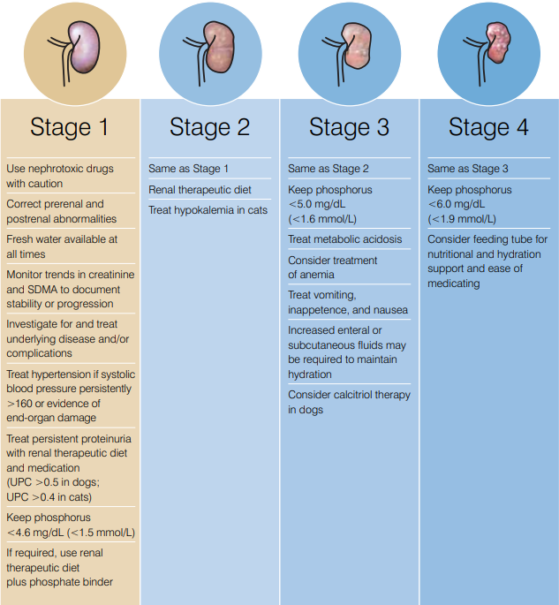

Gastroprotectants, Anti-Emetics, & Appetite Stimulants:
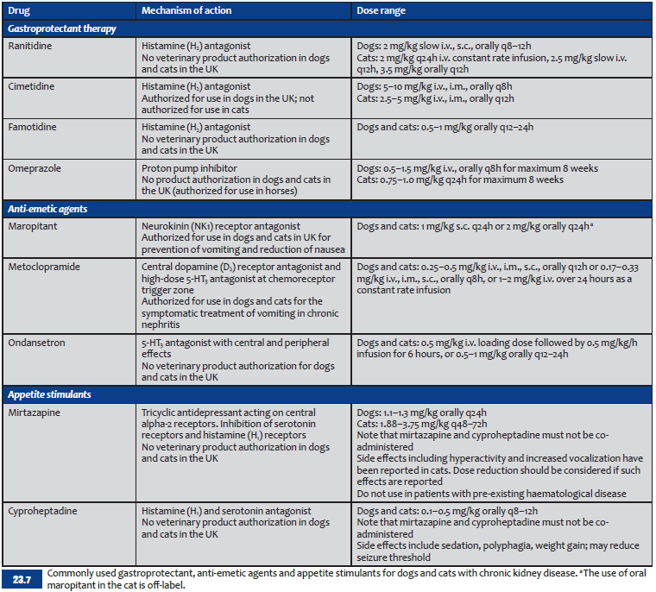

Hypertension Control:

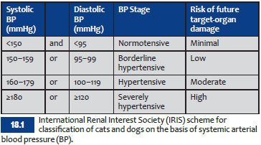
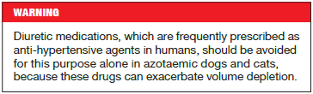
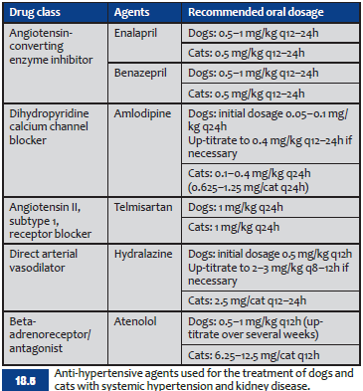
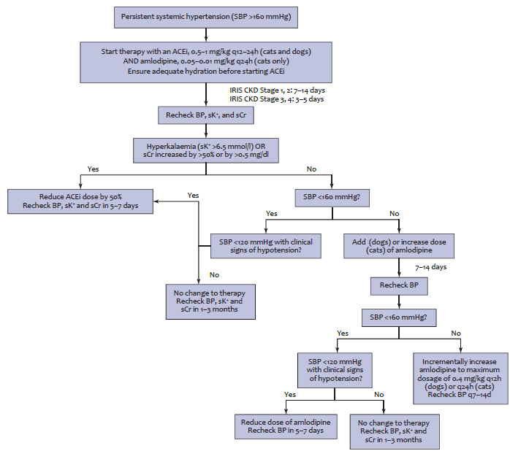
WCVH Choices:
- Amlodipine in cats.
- Calcium channel blockers and/or ACE inhibitors in dogs.

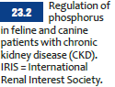
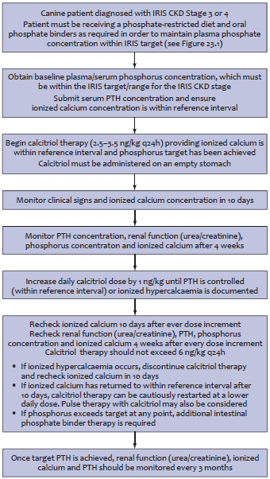
Phosphorus Control:

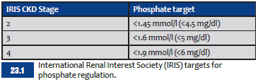
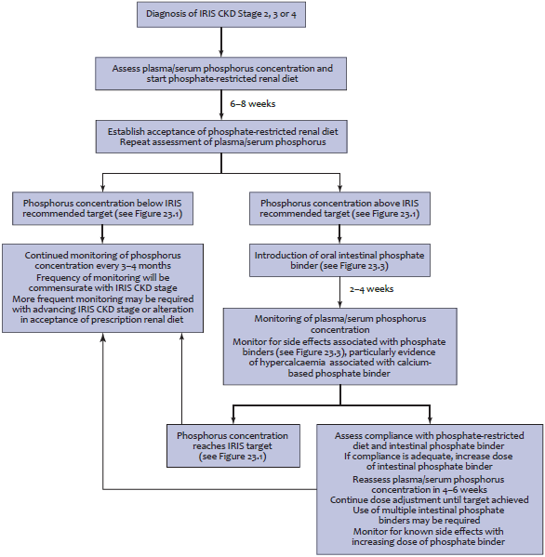

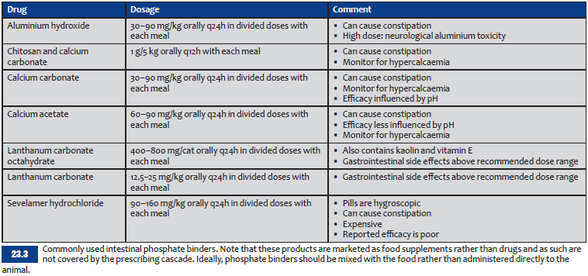

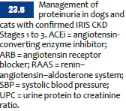
Proteinuria Control:
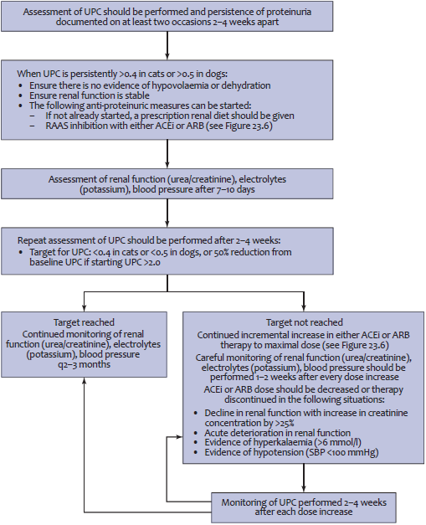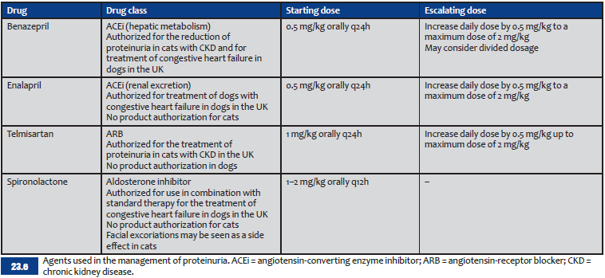
WCVH Choices:
- ACE inhibitors in dogs.
- Semintra in cats.
- Maintain hydration.

Erythrocyte-Stimulating Analogues:

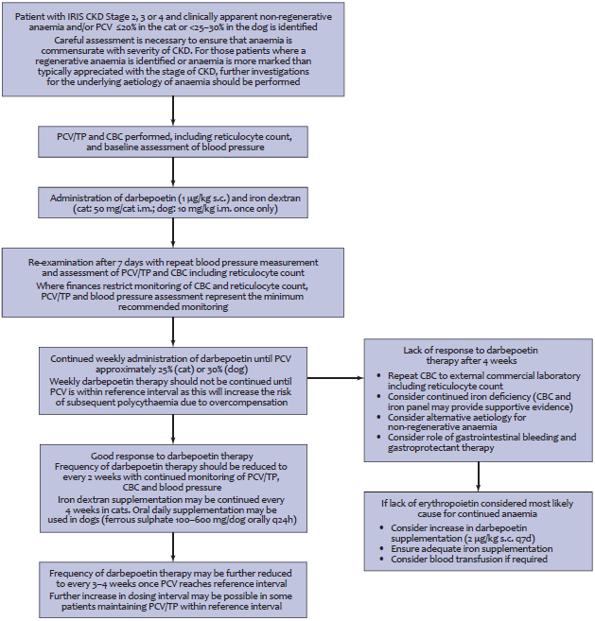

CKD Associated Disorders

Mineral & Bone Disorder (Renal Secondary Hyperparathyroidism):
- As nephrons are lost & renal function declines, the kidneys are less able to excrete phosphorus.
- This alteration in calcium & phosphorus homeostasis results in ↑ parathyroid hormone (PTH).
- ↑ PTH, in the long term, results in metastatic mineralisation of soft tissues.
- Avoid this by restricting phosphate in the diet of CKD animals.

Systemic Hypertension:
- Normally, kidneys are able to regulate the renal blood flow independently of systolic blood pressure – but only within systemic arterial pressures of 70-150 mmHg.
- Outside this range, the kidney can no longer maintain stable glomerular capillary pressures.
- High glomerular pressure (glomerular hypertension) results in damage to the glomerulus (glomerulosclerosis) & secondary proteinuria.
- Avoid this by controlling systemic hypertension.

Proteinuria:
- Occurs in a low level in patients with tubulointerstitial nephritis.
- Occurs at a higher level in patients with glomerular damage.
- When proteins are able to pass through the glomerulus and into the proximal tubular cells, pro-inflammatory mediators are produced which promote tubulointerstitial inflammation.
- Therefore, it is not just about controlling proteinuria to avoid protein loss, but also to avoid further damage to the kidneys.
- Avoid this by feeding a reduced protein diet, supplementing diet with polyunsaturated fatty acid, and controlling hypertension.

